

NAME

–

ANUBHAV GUPTA

ROLL NUMBER

–

2110990227

GROUP NUMBER

–

G5

YEAR

–

3

RD

YEAR (5

TH

SEMESTER)

COURSE INSTRUCTOR

–

LAVISH ARORA SIR



This is how my home page looks, as you can see the website name is “E Market Sphere”, the header allows us to explore other pages , we can also explore the category page through the “explore now!” Button.

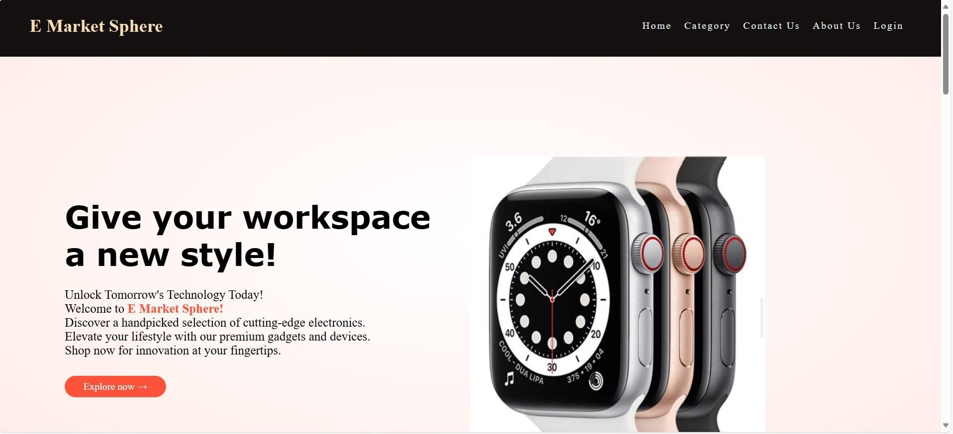

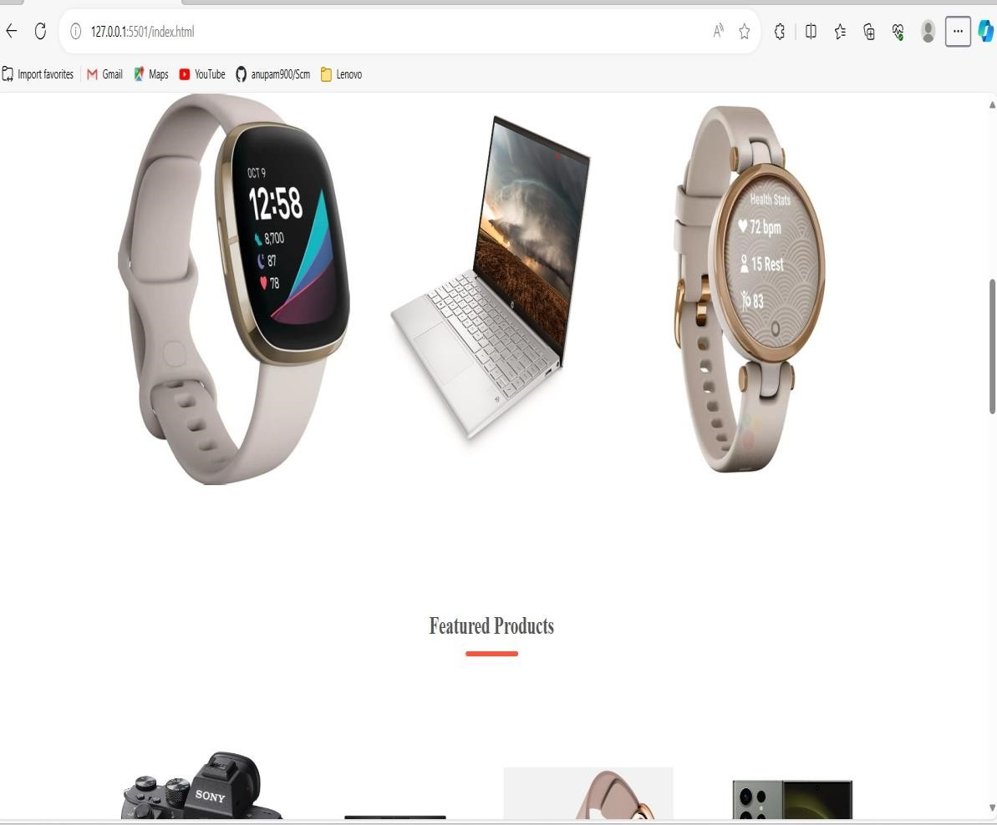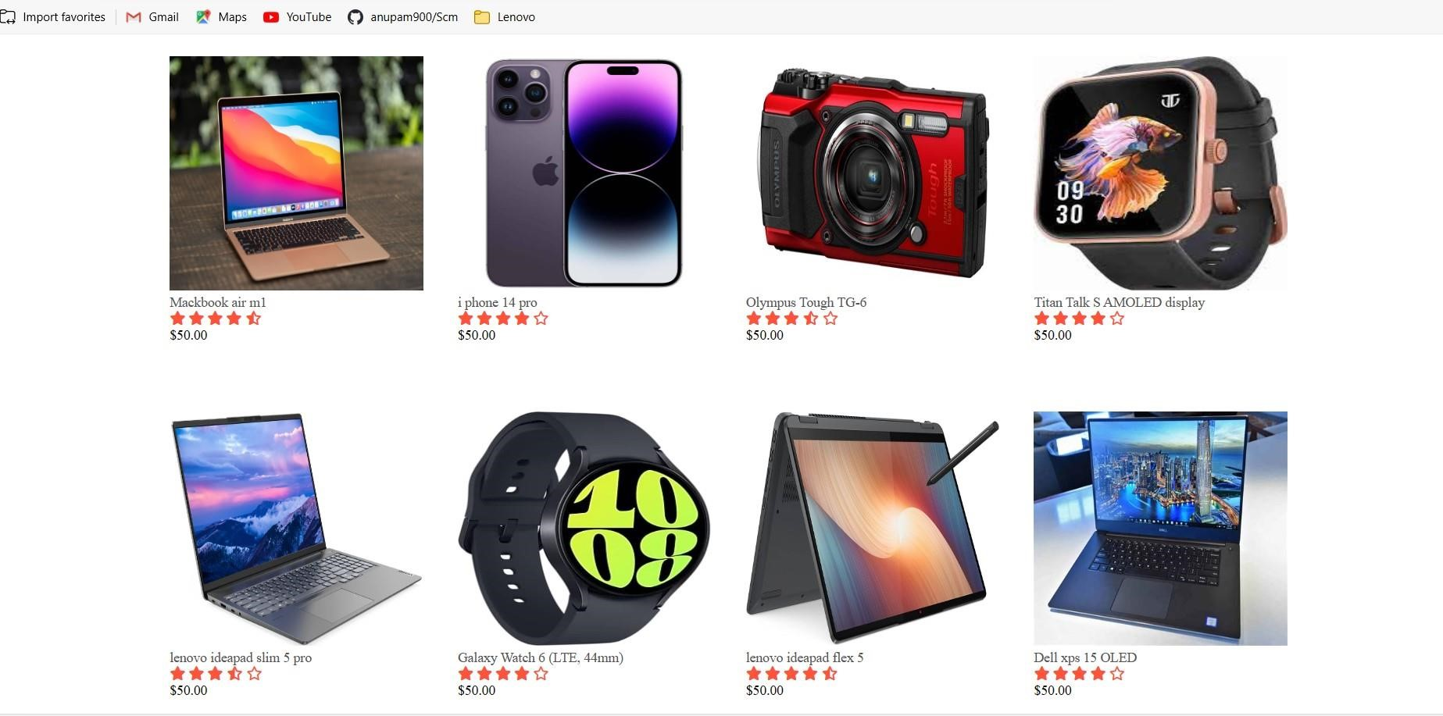

## **This is how the home page looks further on scrolling down.**

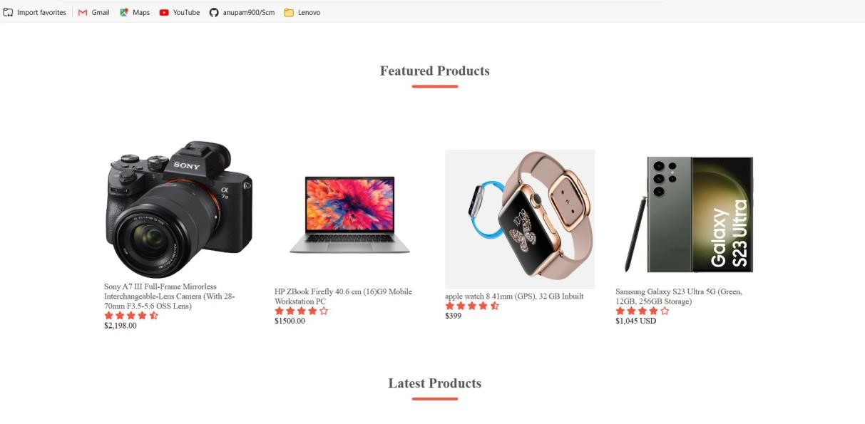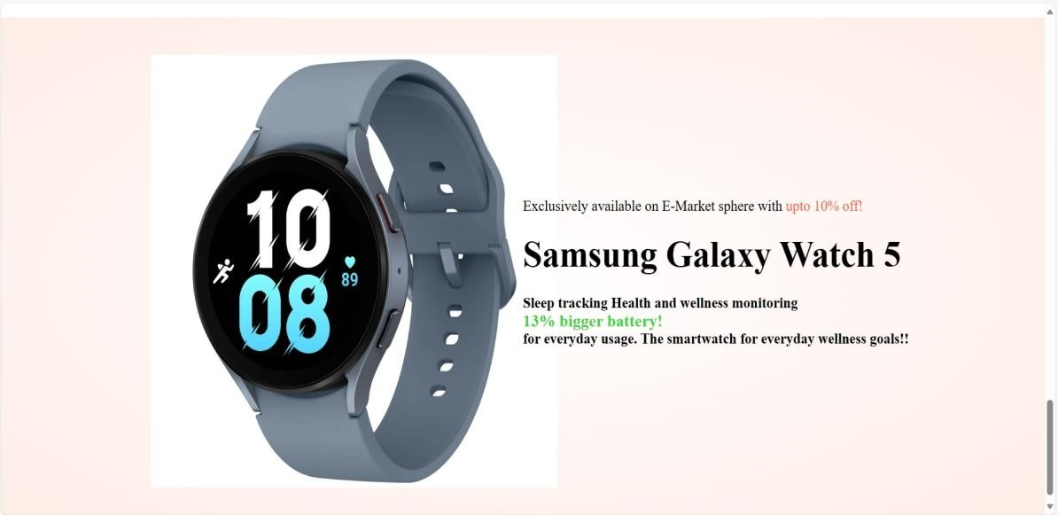

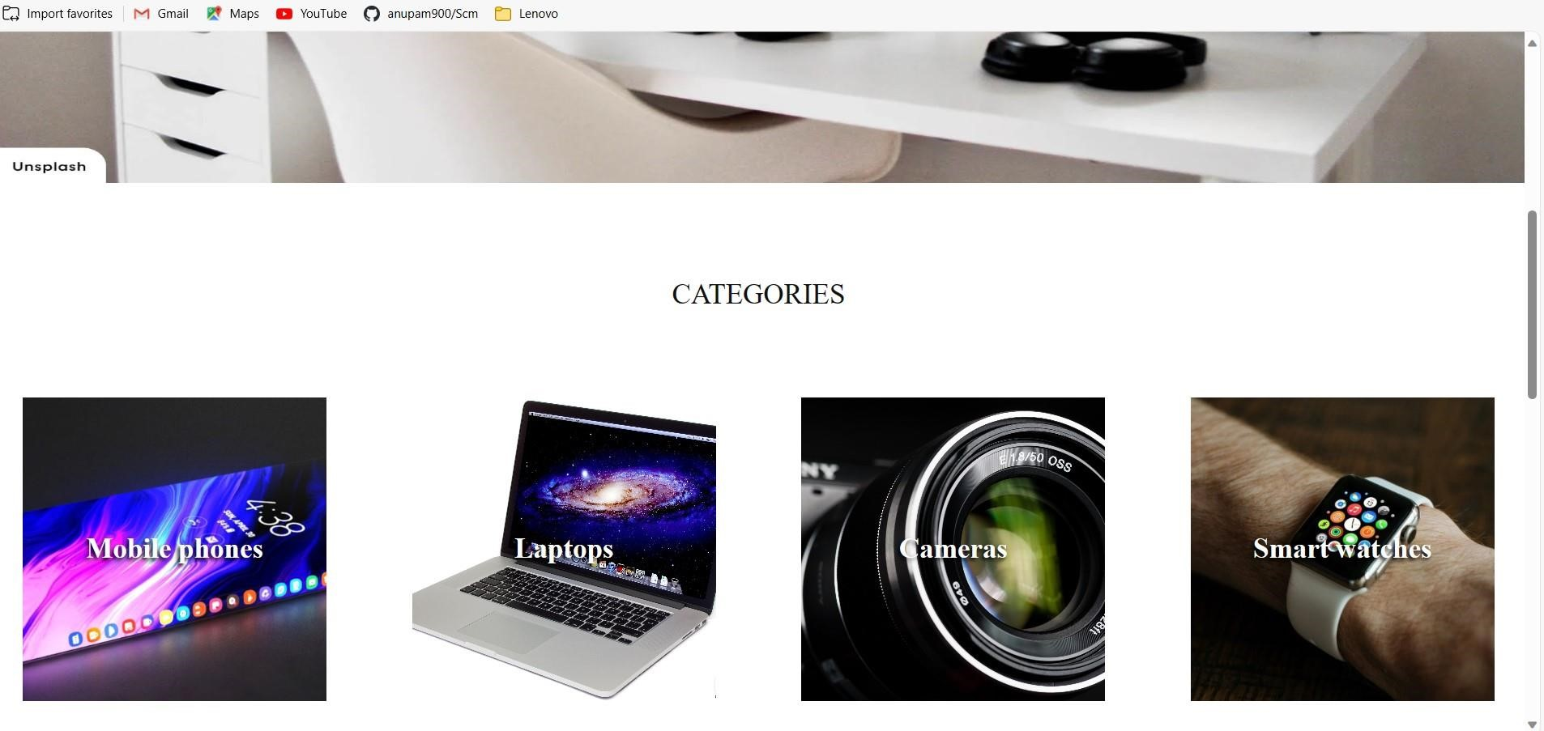Here are the categories I have added in my category page (4 categories; mobiles, laptops, cameras & smartwatches), allowing users to explore a variety of products themselves.

The sub-categories for the categories look like this(this is a demo for mobile but the same design is used for other 3 categories as well), with 8 products for each of the 4 categories

Which are (Mobiles, laptops, cameras, smart watches).

I have used mainly html and CSS to design the cards here in the sub category page also added a header and a footer here.

Here Is the second category which is laptop section to give you a clear overview of how the sub category pages are designed, also I have added shadow-box in CSS to add a 3-D effect on the cards to make it look better and aesthetic.

The third sub category is of the cameras section with a variety of specifically hand picked best cameras for every usage with an affordable price.

here is the last sub category we have in our E market Sphere website which is the smart watches section, I did extremely good research for this section as well to pick the best smart watches for all types of buyers.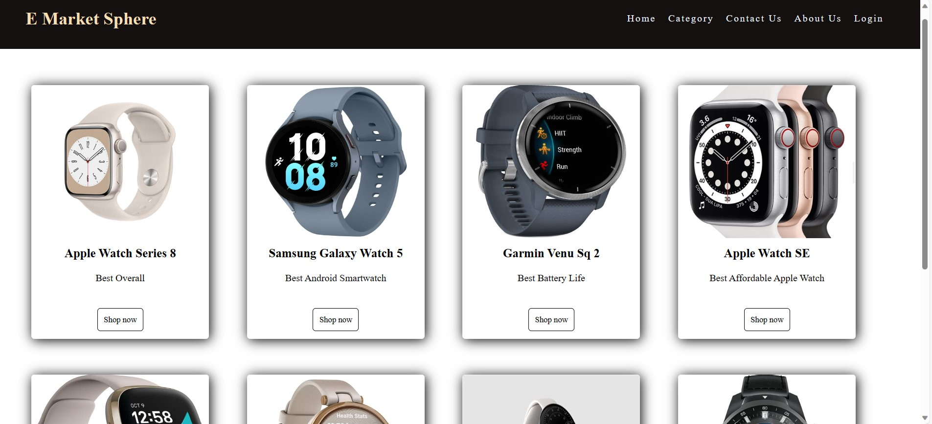

so, I have linked these all-sub category pages to different pages via the shop now button which takes us further into the website and opens the specific product you choose in short, every product is given a unique id and class so that which ever “buy now” button you click it will take you to that specific product only.A screenshot of a computer

* I faced a lot of challenges while implementing JavaScript in this code
* I am not complaining about it because it was the only and only best way to learn the implementation of the JavaScript logic in the code.
* Because the idea I had in my mind was very intriguing and innovative because as you can see in the above slide, I have added a short description in the right side of the image of the specific product.
* Also, the price is added but below the price is a read more button which is a Modal window and the read more button when clicked uses the JavaScript logic to open the modal window which has the specifications of the product whose read more button you are clicking on
* the new modal window has various other JavaScript logics applied to it as well, it has a cross button to close the window.
* We can also close the modal window by clicking outside the modal window.
* The most interesting feature I added in the modal window was the closing of the modal window by pressing the Esc(escape) key.
* Here is the sample of what the modal window looks like in website with all the specifications of the particular product mentioned.A screenshot of a computer

  Description automatically generated

Here are other samples of modal windows with different designs I have used in my project and it makes the specs look cleaner and better this way also the user does not have to click on any other buttons to get to know more about the product.A screenshot of a computer

* Here is another example of some good usage of emojis in the specifications to make them more interesting and better to understand for the buyers.

Some other pages are left one of them is contact us page.

With a header and a footer plus an extendable “your message” box to fit long essays as well!

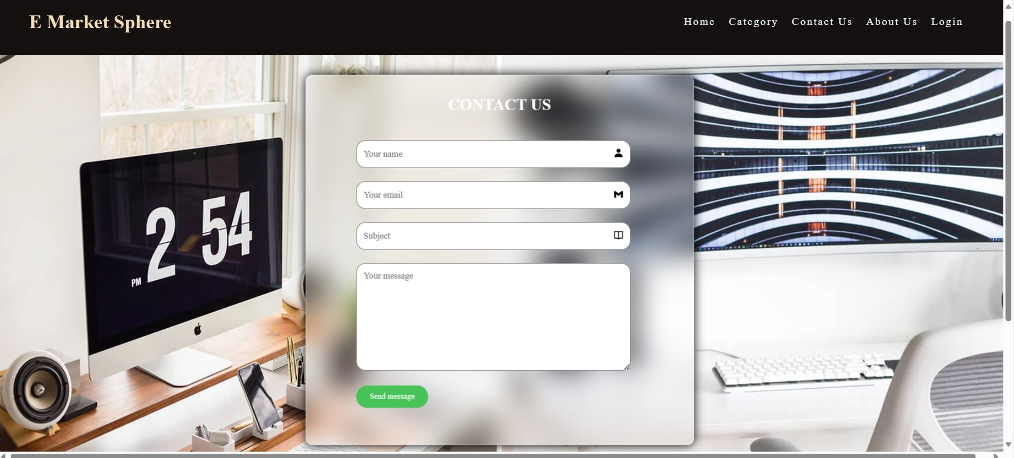

* Here is the login page which I built mainly using HTML and CSS and bit of bootstrap (making and achieving 12, by diving columns and rows in an algorithmic way).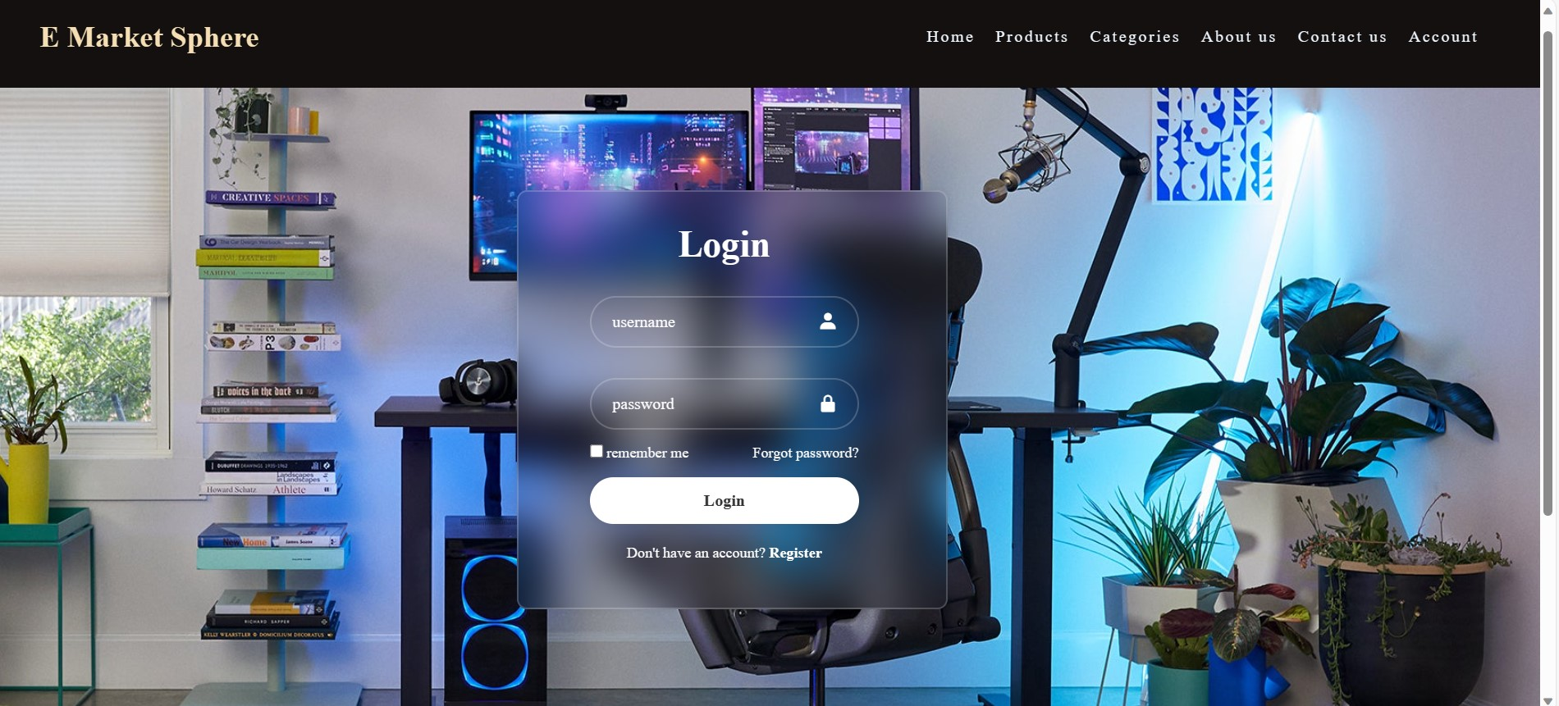

Here is the about us page as well to get to know more about the website and the creators as well, if any customer is interested in exploring more or diving deep in our website. A screenshot of a website

* This project really helped me to learn more about HTML, CSS & JavaScript in depth also helped me learn how to manage all these languages together to create a project.
* Lavish sir helped me grasp the concepts about the front-end web development in a better and efficient way
* I can even go further and break my limits by learning how to build web applications, make APIs etc.
* Also, I learned how to decouple different languages to receive data in order to make the code work and later on make the project successful
* I have a strong grip on the basics now so if any front end related work is required by any company my chances to get selected are higher now all credit goes to this project to help me learn these small but important details about web development.

**THANK YOU!!**